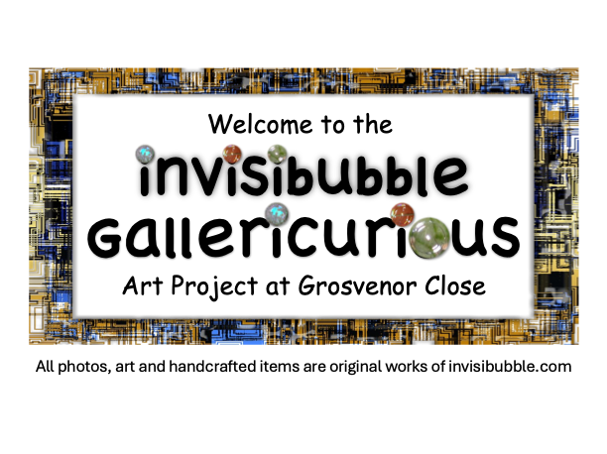 |  | Price List (June 2025 v1.0)
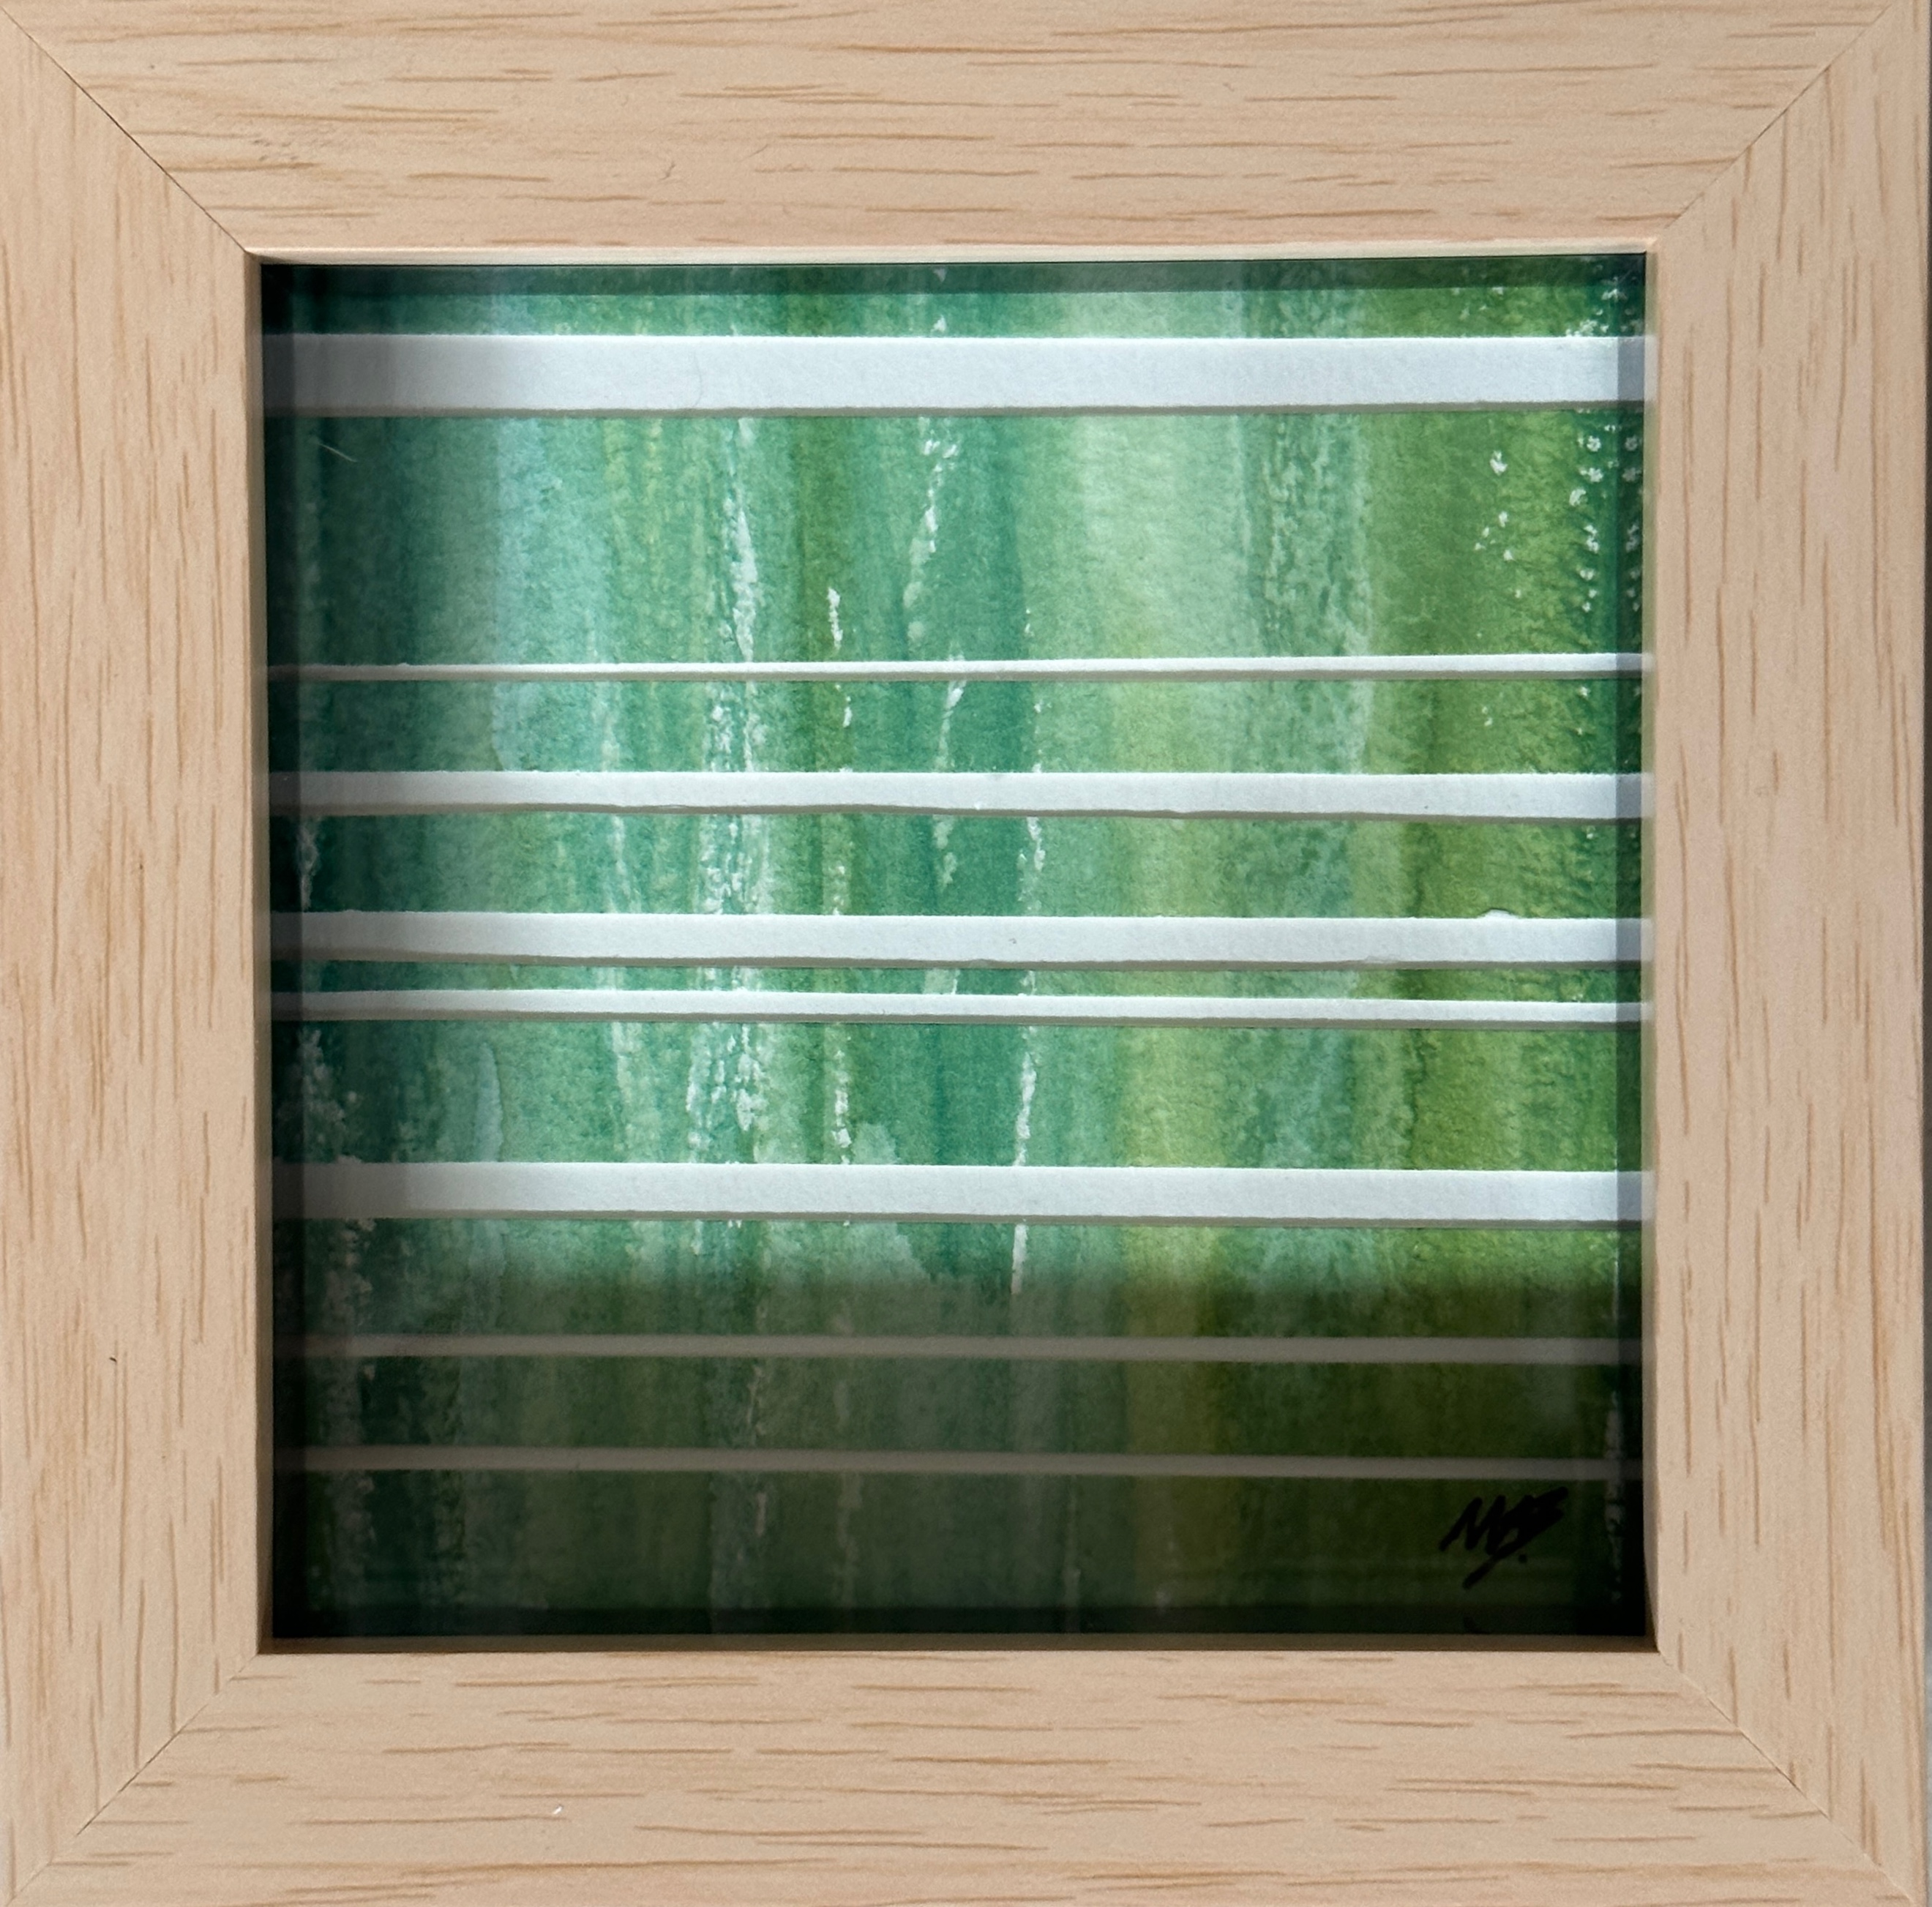 | Space Between the Grasses I (2025)  Watercolour, 10x10cm in light wood effect acrylic box frame  (outer dimensions 12.4x12.4x3.4cm) |  | £24.99
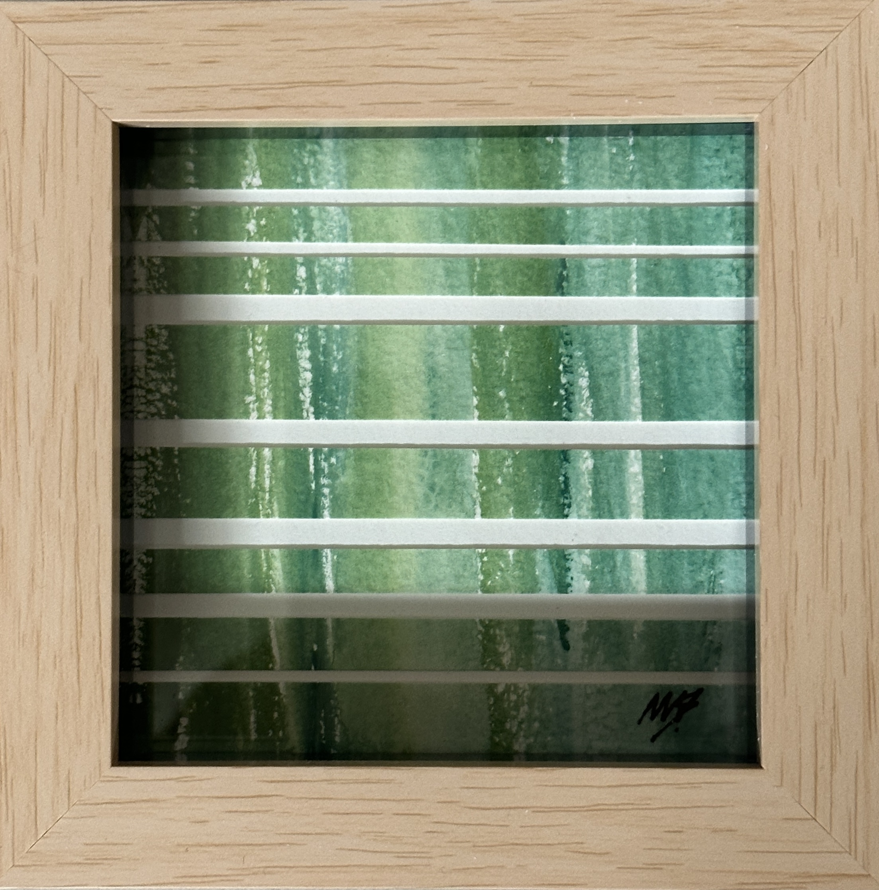 | Space Between the Grasses II (2025)  Watercolour, 10x10cm in light wood effect acrylic box frame  (outer dimensions 12.4x12.4x3.4cm) |  | £24.99
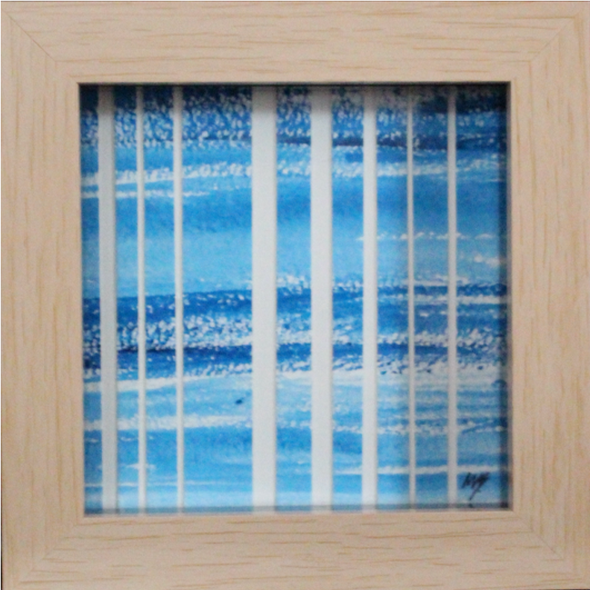 | Space Between the Ripples (2025)  Watercolour, 10x10cm in light wood effect acrylic box frame  (outer dimensions 12.4x12.4x3.4cm) |  | £24.99
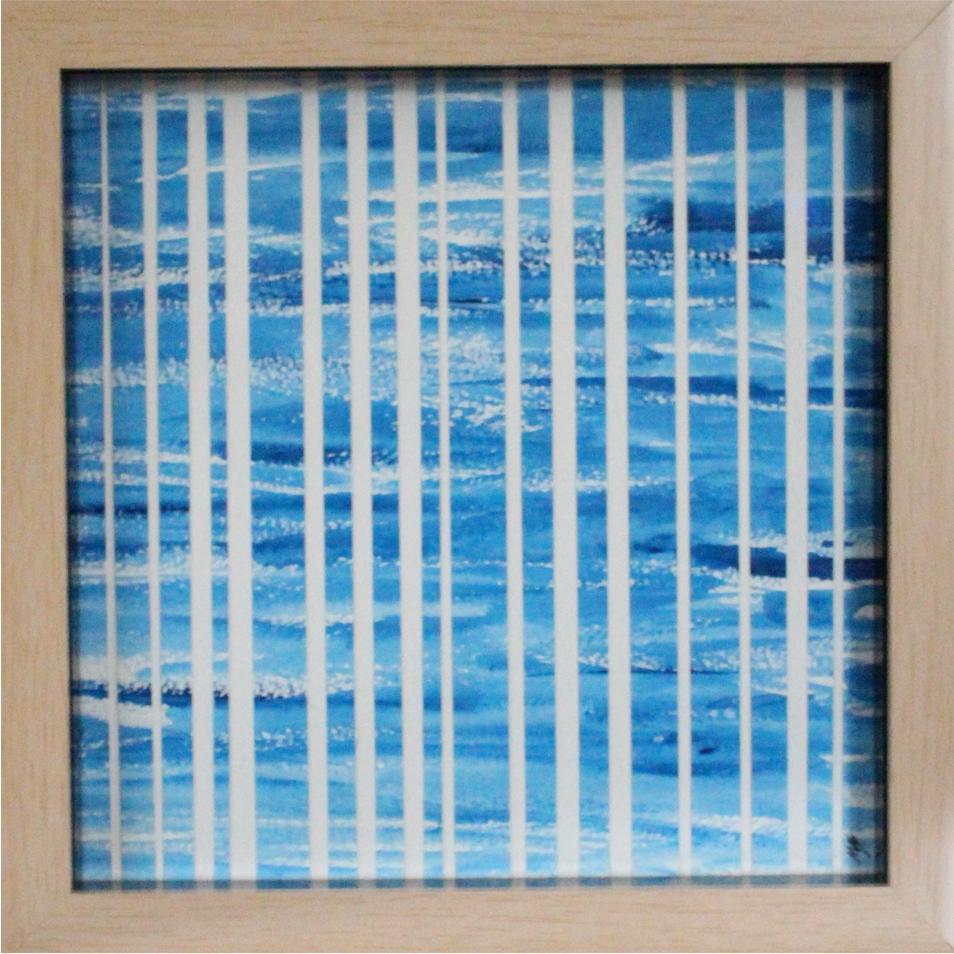 | Space Between the Waves (2025)  Watercolour, 20x20cm in light wood effect acrylic box frame  (outer dimensions 22.5x22.3x3.4cm) |  | £34.99
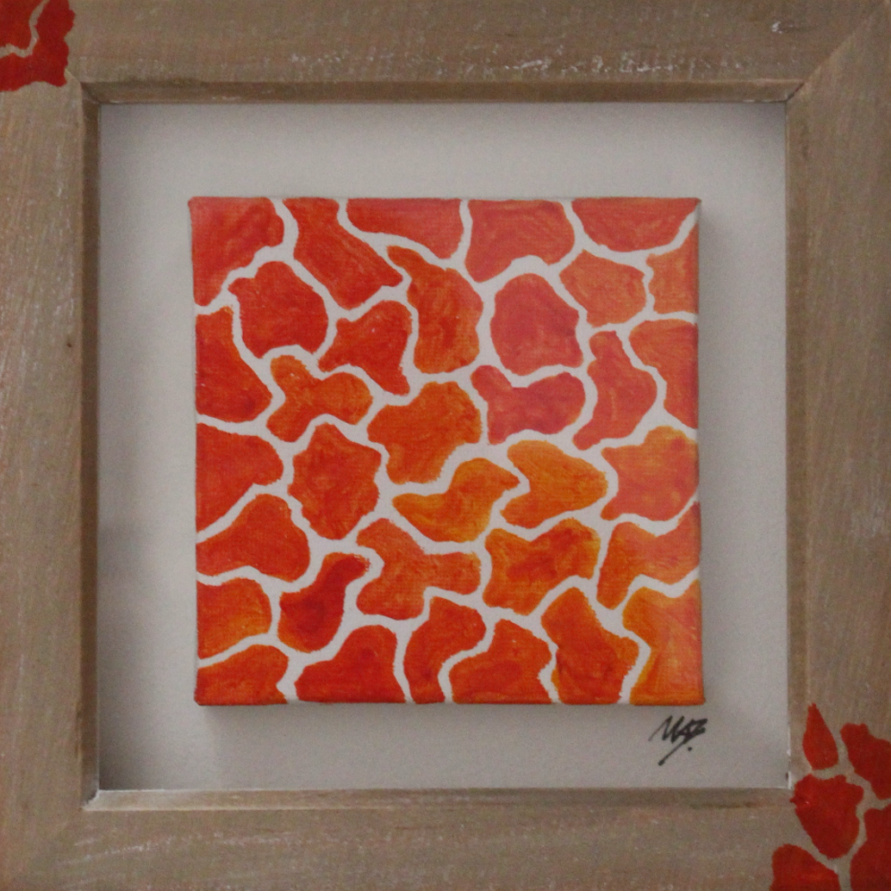 | Crazee Orange (2024)  Acrylic on canvas, 14x14cm in washed wood box frame (no glass).  (outer dimensions 18x18x3.2cm) |  | £19.99
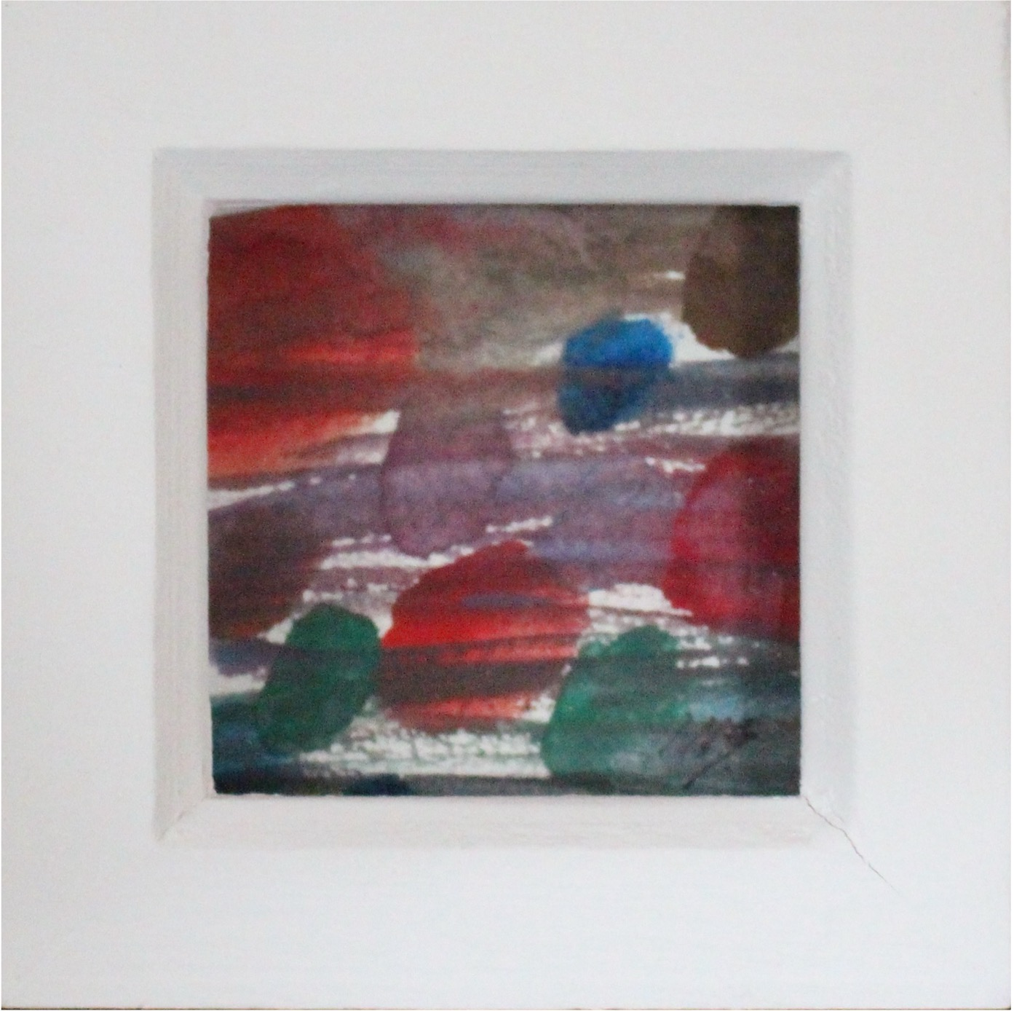 | Warm Wet Dots (2025)  Watercolour, 7x7cm in white wood box frame.  (outer dimensions 10.6x10.6x3.5cm) |  | £19.99
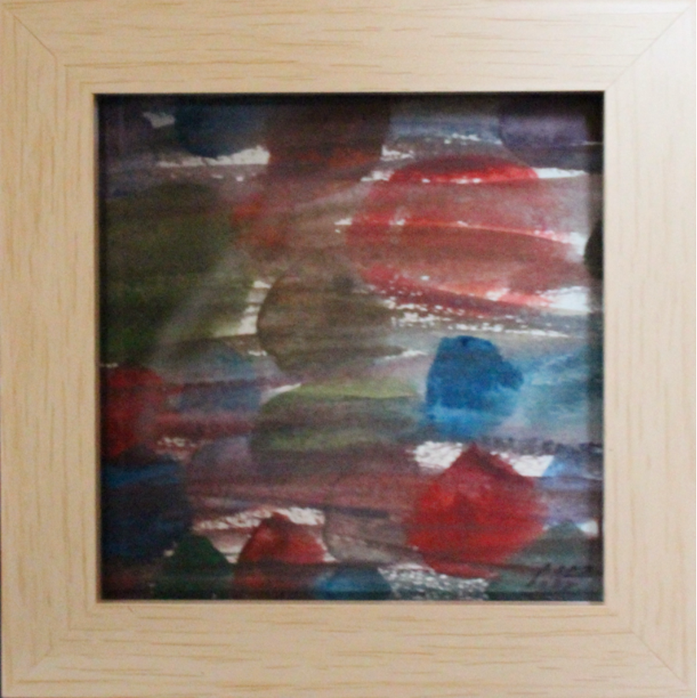 | Warm Wet Circles (2025)  Watercolour, 10x10cm in light wood effect acrylic box frame  (outer dimensions 12.4x12.4x3.4cm) |  | £24.99
Please get in touch at marcus@invisibubble.com if you are interested in purchasing any of the items.

Payment by bank transfer, PayPal or in person can be arranged.

All items available for collection from the Ipswich area or can be posted Royal Mail Tracked 48 or similar (included in price).

 |  |  | 

